EXPERIMENTAL OBJECTIVES
- Observe the effect of learning and the effect of anticipating the stimulus delivery on reaction time.
- Compare reaction times in four stimulus-response situations:
  - Fixed interval stimulus presentation using the dominant hand for the response.
  - Random interval stimulus presentation using the dominant hand for the response.
  - Fixed interval stimulus presentation using the nondominant hand for the response.
  - Random interval stimulus presentation using the nondominant hand for the response.
3. Compare the reaction times for groups of subjects by calculating the statistics of group mean, variance, and standard deviation in each of the four stimulus-response situations.

MATERIALS
- BIOPAC Hand Switch (SS10L)
- BIOPAC Headphones (OUT1 or OUT1A*)
- Biopac Student Lab System: BSL 4 software, MP36 or MP35 hardware
- Computer System (Windows or Mac)

EXPERIMENTAL METHODS

SetUp
FAST TRACK Setup | Detailed Explanation of Setup Steps
- Turn your computer ON.
- Turn OFF MP36/35 unit.  - Plug the equipment in as follows:  Hand Switch (SS10L) — CH 1  Headphones (OUT1 or OUT1A*) — back of unit  *OUT1A is compatible with MP36 only.  - Turn ON the MP36/35 unit.  - Start the BIOPAC Student Lab Program. | 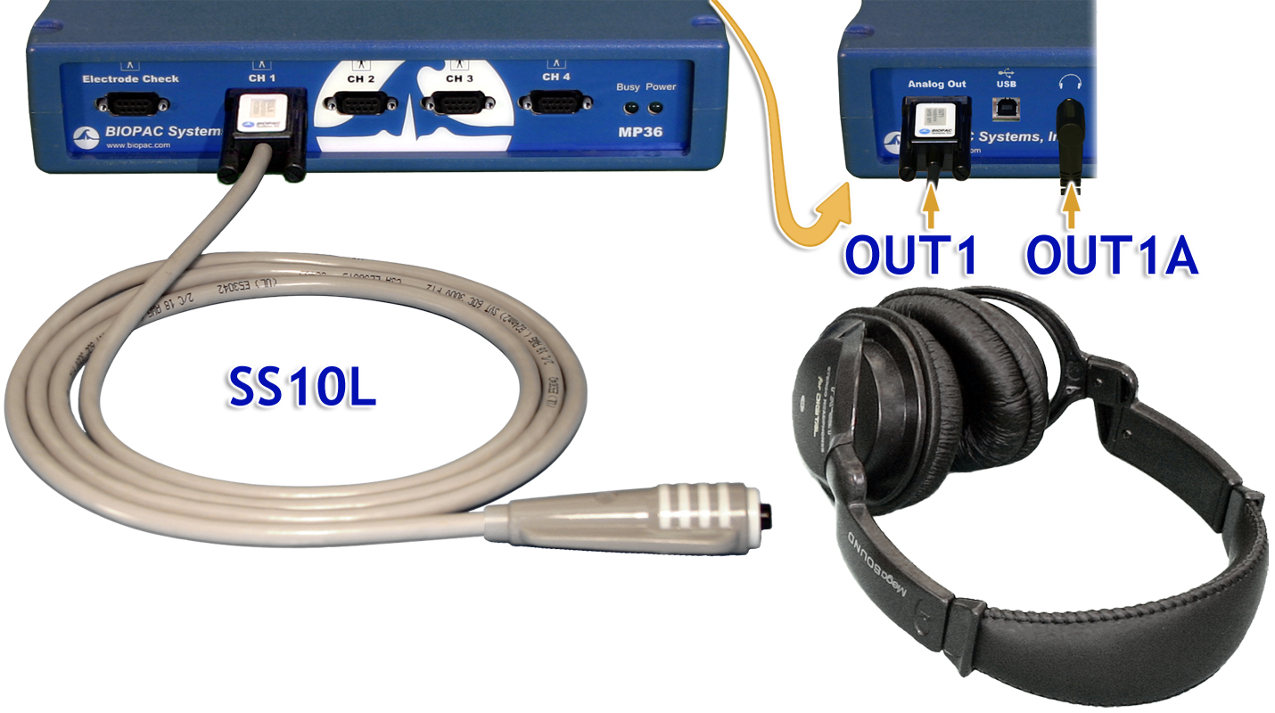  Fig. 11.3 Equipment Connections
- Choose lesson “L11 – Reaction Time I” and click OK.  - Type in a unique filename and click OK.  Setup continues… | Start Biopac Student Lab by double-clicking the Desktop shortcut.  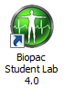  No two people can have the same filename, so use a unique identifier, such as Subject’s nickname or student ID#.  A folder will be created using the filename. This same filename can be used in other lessons to place the Subject’s data in a common folder.
- Optional: Set Preferences.  - Choose File > Lesson Preferences.  - Select Headphone Volume.  - Set the desired volume and click Apply.  END OF SETUP |  | This lesson has an optional Preferences setting for headphone volume:  Headphone Volume: Increase or decrease volume as desired.  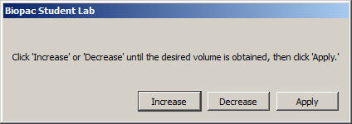  Lesson Recordings: Specific recordings may be omitted based on instructor’s preferences.

B. B. CALIBRATION
This calibration procedure will check that the headphones and SS10L are properly connected. Pay close attention to Calibration.
FAST TRACK Calibration | Detailed Explanation of Calibration Steps
- Prepare the Subject for the calibration recording.  - Put headphones on.  - Get in a seated and relaxed position, with eyes closed.  - Hold hand switch in dominant hand, with thumb is ready to press the button. | 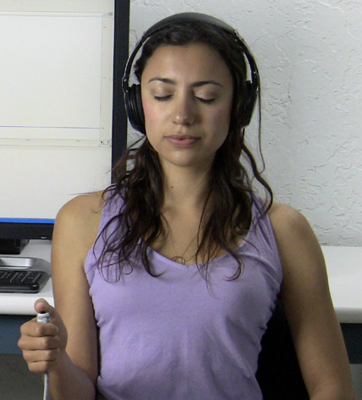  Fig. 11.4
- Click Calibrate.  - Subject must press hand switch button after click is heard, and then release. | The click will be heard approximately four seconds into the recording.
- Wait for Calibration to stop. | Calibration lasts eight seconds.
- Verify recording resembles example data.  - If similar, click Continue and proceed to Data Recording.  - If necessary, click Redo Calibration.  END OF CALIBRATION | The switch response should be clearly seen near the middle of the screen.  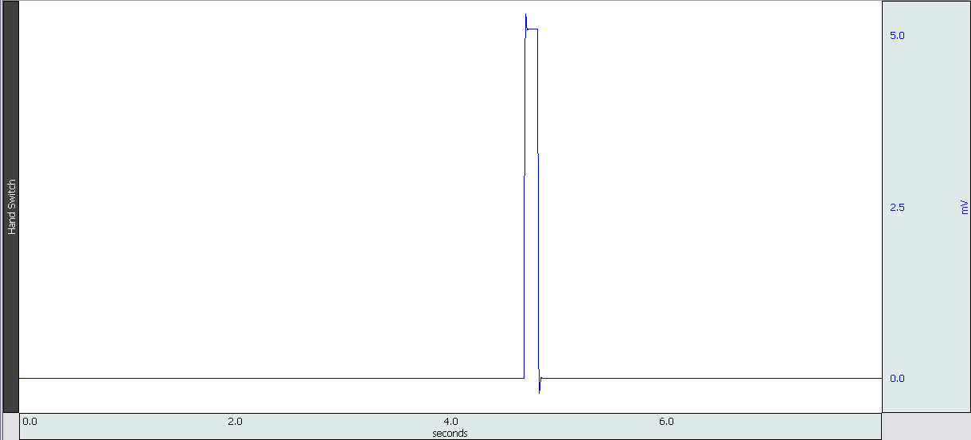  Fig. 11.5 Example Calibration data  If recording does not resemble Example Data...  - If no switch response is detected, check all connections.  - If the baseline signal is excessively noisy (greater than 5 mV peak-to-peak,) there may be a computer grounding problem. Make sure the computer power cord and outlet uses all 3 prongs. If using a laptop, try disconnecting the power supply.  - If no click was heard, check headphone connections and volume level.  - If the Calibrate button reappears in the window, the switch response was not detected. Check connections and repeat the calibration procedure, making sure to press the button firmly.  - If multiple responses are present, redo and be sure to press hand switch button only once during Calibration.
- DATA Recording
FAST TRACK Recording | Detailed Explanation of Recording Steps
- Prepare for the recordings.  - Subject is seated with eyes closed.  - Subject holds switch in dominant hand, with thumb ready to press the button. | Four data recordings will be acquired*, each requiring Subject to press the button (response) as soon as possible after hearing a click (stimulus):  - Recordings 1 and 3 present the stimuli at random (1 – 10 second) intervals, alternating between dominant and nondominant hand.  - Recordings 2 and 4 present the stimuli at fixed intervals (every 4 seconds,) alternating between dominant and nondominant hand.  Notes:  - If the Subject is right-handed, the right hand is generally dominant; if the subject is left-handed, the left hand is generally dominant.  - This lesson measures reaction time, so pressing the hand switch immediately after a click is heard is important.  - This procedure assumes that all lesson recordings are enabled in Lesson Preferences, which may not be the case for your lab. Always match the recording title to the recording reference in the journal and disregard any references to excluded recordings.  - The reaction time summaries will be calculated and placed in the journal automatically at the end of the lesson. The software looks for one response per stimulus, and ignores responses that occur before the stimulus or more than one second after the stimulus. The threshold the program uses to calculate reaction time is 1.5 mV.  - DO NOT manually insert event markers during this lesson as this could cause incorrect reaction time calculations.
Random interval - dominant hand
- Click Record.
- Subject must press hand switch button immediately after each click is heard, and then release.  - Wait for recording to stop. | The recording will stop after ten clicks.
- Verify recording resembles example data.  - If similar, click Continue and proceed to the next recording.  Recording continues… | A pulse should be displayed after each event marker if the switch was pressed correctly. Use the horizontal scroll bar to look back on earlier portions of the recording.  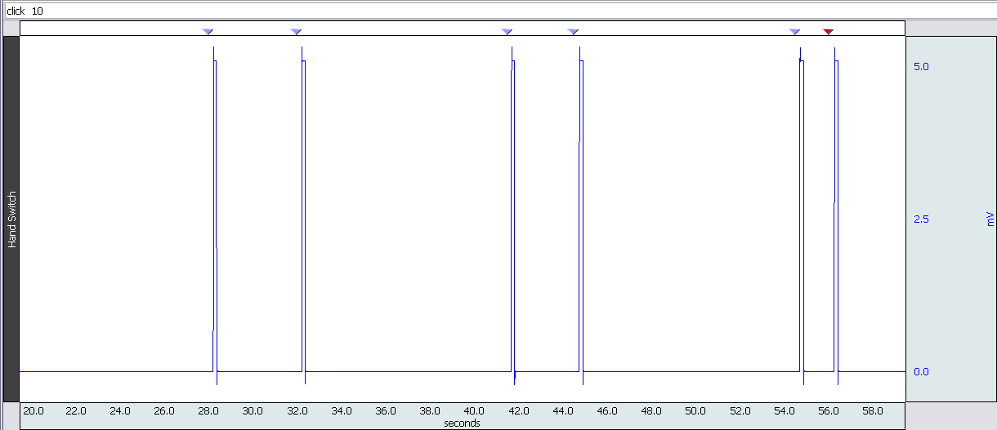  Fig. 11.6 Example Random interval data

- If necessary, click Redo.  - If all required recordings have been completed, click Done. | The data might be different for the following reasons:  - If data is flatline, check all connection to MP unit.  - The recording did not detect a switch response for each click. Make sure the switch is pressed firmly. You can miss some responses, but if you miss more than two, you should consider redoing the recording.  - The switch response (pulse) occurs before the event marker, indicating the Subject responded prematurely.  If necessary, click Redo and repeat Steps 2 – 5. Note that once Redo is clicked, the most recent recording will be erased.
Fixed interval – dominant hand
- Prepare for the recording.
- Subject is seated with eyes closed.
- Subject holds switch in dominant hand, with thumb ready to press the button.
- Click Record.
- Press hand switch button immediately every time a click is heard.  - Wait for recording to stop. | The recording will stop after ten clicks.
- Review the data on the screen.  - If similar to Fig. 11.6, click Continue and proceed to the next recording.  - If necessary, click Redo.  - If all required recordings have been completed, click Done. | See details in Step 5.  If necessary, click Redo and repeat Steps 7 – 10. Note that once Redo is clicked, the most recent recording will be erased.
Random interval –nondominant hand
- Prepare for the recording.
- Subject is seated with eyes closed.
- Subject holds switch in nondominant hand, with thumb ready to press the button.
- Click Record.
- Press hand switch button immediately every time a click is heard.
- Wait for recording to stop.
- Review the data on the screen.  - If similar to Fig. 11.6, click Continue and proceed to the next recording.  - If necessary, click Redo.  - If all required recordings have been completed, click Done. | See details in Step 5.  If necessary, click Redo and repeat Steps 12 – 15. Note that once Redo is clicked, the most recent recording will be erased.
Fixed interval – nondominant hand
- Prepare for the recording.  - Subject is seated with eyes closed.  - Subject holds switch in nondominant hand, with thumb ready to press the button.  - Click Record. | Recording continues…
- Press hand switch button immediately every time click is heard.
- Wait for recording to stop.
- Verify a response follows each event marker.  - If similar to Fig. 11.6, click Continue and proceed to the optional recording section or click Done to end the lesson.  - If necessary, click Redo. | See details in Step 5.  If necessary, click Redo and repeat Steps 17 – 20. Note that once Redo is clicked, the most recent recording will be erased.
OPTIONAL Active Learning Portion  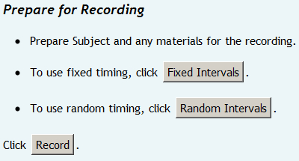 | With this lesson you may record additional data by clicking Continue following the last recording. Design an experiment to test or verify a scientific principle(s) related to topics covered in this lesson. Prior to recording additional data, choose the desired audio stimulus interval (random or fixed,) as shown on left.  Design Your Experiment  Use a separate sheet to detail your experiment design, and be sure to address these main points:  - Hypothesis  Describe the scientific principle to be tested or verified.  - Materials  List the materials you will use to complete your investigation.  - Method  Describe the experimental procedure—be sure to number each step to make it easy to follow during recording.  Run Your Experiment  - Set Up  Set up the equipment and prepare the subject for your experiment.  - Record  Use the Continue, Record and Suspend buttons to record as much data as necessary for your experiment.  Click Done when you have completed all of the recordings required for your experiment.  Analyze Your Experiment  Set measurements relevant to your experiment and record the results in a Data Report.
- Click Done.  END OF RECORDING | When Done is clicked, a dialog with options will be generated. Make a selection and click OK.  If choosing the Record from another Subject option:  - Repeat Calibration Steps 1 – 3, and then proceed to Recording.

DATA ANALYSIS
FAST TRACK Data Analysis | Detailed Explanation of Data Analysis Steps
- Enter the Review Saved Data mode.  - Note channel designation:  Channel Displays  CH 1 Hand Switch  - Note measurement box settings:  Channel Measurement  CH 1 Delta T | If entering Review Saved Data mode from the Startup dialog or Lessons menu, make sure to choose the correct file.  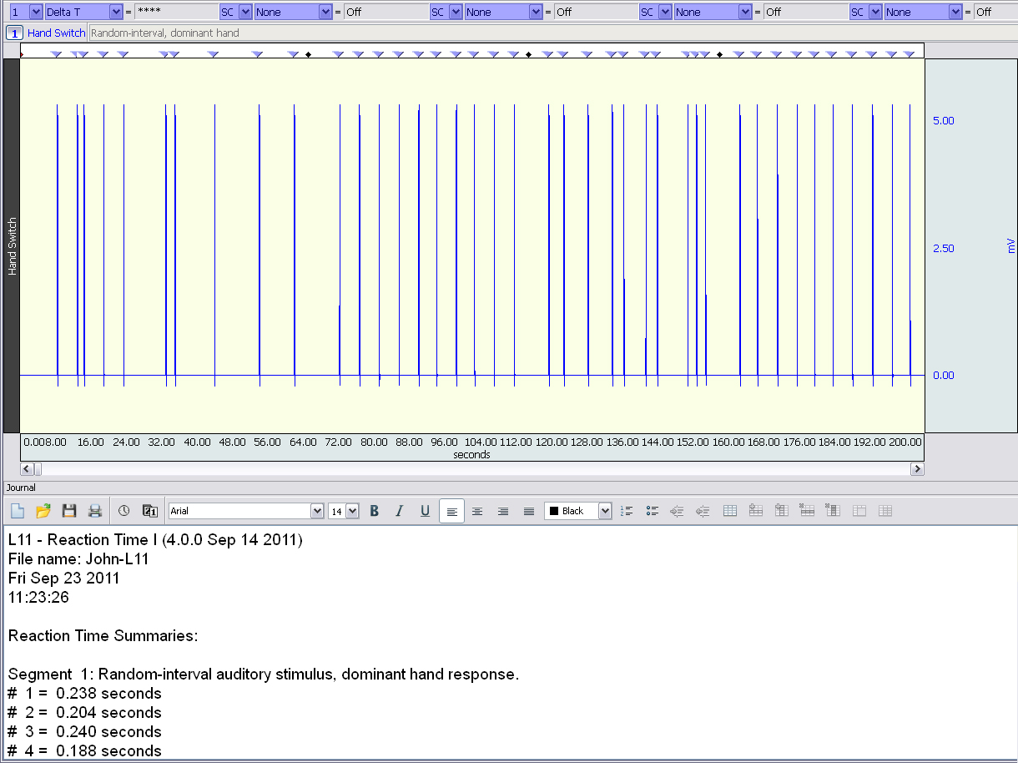  Fig. 11.7 Example Data and journal  The measurement boxes are above the marker region in the data window. Each measurement has three sections: channel number, measurement type, and result. The first two sections are pull-down menus that are activated when you click them.  Brief definition of measurements:  Delta T: Displays the amount of time in the selected area (the difference in time between the endpoints of the selected area).  The “selected area” is the area selected by the I-Beam tool (including the endpoints).  Note The Journal contains the reaction time summary. Use this to fill in your data report.
- Set up your display window for optimal viewing of the first event marker and pulse of the first data recording (Fig. 11.8).  Data Analysis continues… | 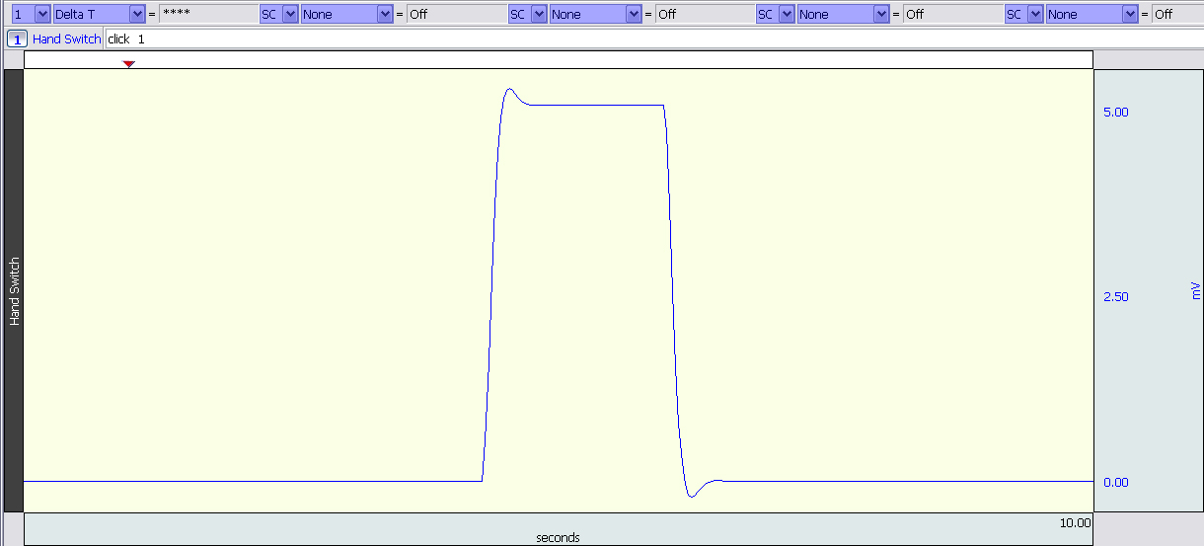  Fig. 11.8 Zoomed in on First event marker and switch pulse  Note: The append event markersmark the beginning of each recording. Click on (activate) the event marker to display its label.  Useful tools for changing view:  Display menu: Autoscale Horizontal, Autoscale Waveforms, Zoom Back, Zoom Forward  Scroll Bars: Time (Horizontal); Amplitude (Vertical)  Cursor Tools: Zoom Tool  Buttons: Show Grid, Hide Grid, -,+
- Select an area from the first event marker to the leading edge of the first pulse (Fig. 11.9) and note the Delta T measurement.   A | The first event marker indicates the start of the stimulus click. The leading edge of the pulse indicates when the button was first pressed. The threshold that the program uses to calculate reaction time is 1.5 mV.  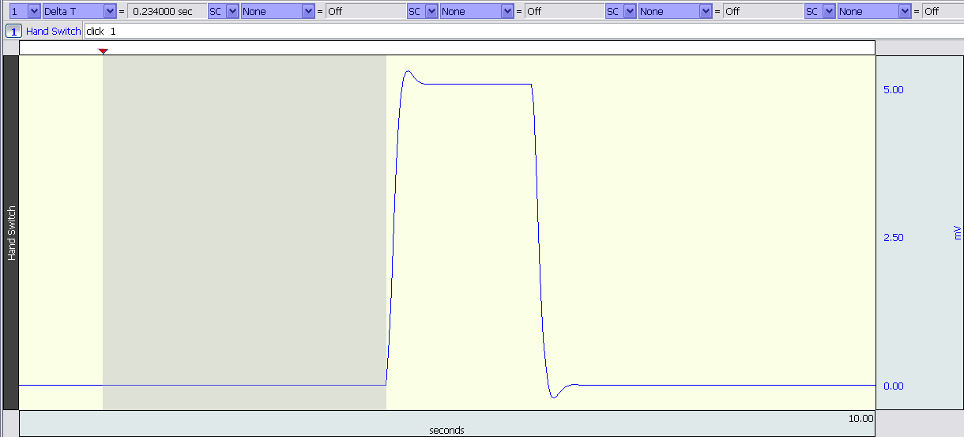  Fig. 11.9 Example reaction time measurement.
- Look at the first reaction time result in the Journal and compare this to the Delta T measurement found above. | The two measurements should be approximately the same.
- Repeat the steps above on other pulses until you are convinced that the Journal readings are accurate.
- Transfer your data from the Journal to the Data Report.   B  - Collect data from at least five other students in your class as needed to complete the Data Report.   C, D, E | This step may not be necessary if your Instructor allows you to print out your Journal and staple it to the Data Report.  Hint: Measurements and formulas can be pasted directly into the Journal Data Report table cells by right-clicking into the desired table cell and selecting the measurement from the contextual menu. (See below)  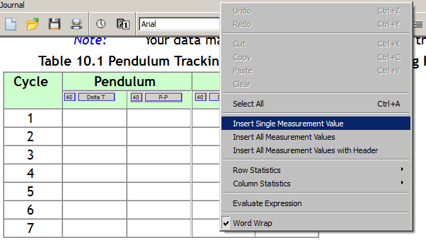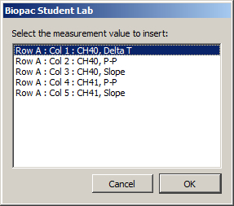  Fig. 11.10 Pasting measurements to Data Report  Note that the Variance and Standard Deviation calculations in Tables 11.4 and 11.5 are optional and depend on the requirements of your instructor.
- Save or Print the data file.  - Quit the program.  END OF DATA ANALYSIS | An electronically editable Data Report can be found in the journal (following the lesson summary,) or immediately following this Data Analysis section. Your instructor will recommend the preferred format for your lab.
____________________________________________________________________________________________________
End of Lesson 11
Complete the Lesson 11 Data Report that follows
___________________________________________________________________________________________________
REACTION TIME
DATA REPORT
Student’s Name:

Lab Section:

Date:
- Data and Calculations
Subject Profile
Name: Height:
Age: Gender: Male / Female Weight:
- Manual calculation of reaction time
Calculate the reaction time for the first click in initial recording: Delta T =
- Summary of Subject’s Results (copy from the software Journal)
Table 11.1
STIMULUS  NUMBER | REACTION TIMES (ms)
STIMULUS  NUMBER | Dominant Hand |  | Nondominant Hand
STIMULUS  NUMBER | (Random) | (Fixed interval) | (Random) | (Fixed interval)
1
2
3
4
5
6
7
8
9
10
Mean
- Comparison of reaction time to number of presentations
Complete Table 11.2 with data from the first “Random Data (Dominant)” and “Fixed Interval Data (Dominant)” trial for 5 students . Calculate the mean for each presentation to determine if reaction times vary as each Subject progresses through the series of stimulus events.
Table 11.2 Comparison of Reaction Times
Student’s | Random Data (Dominant Hand) |  |  | Fixed Interval Data (Dominant Hand)
Name | Stimulus 1 | Stimulus 5 | Stimulus 10 | Stimulus 1 | Stimulus 5 | Stimulus 10
1.
2.
3.
4.
5.
Calculate the Means:
- Group Summary
Complete Table 11.3 with the mean for 5 students and calculate the group mean.
Table 11.3
Class Data | Random trials |  | Fixed-interval trials
Student Means | Dominant Hand | Nondominant Hand | Dominant Hand | Nondominant Hand
1.
2.
3.
4.
5.
Calculate the Group Means:
- Variance and Standard Deviation (Optional)
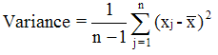
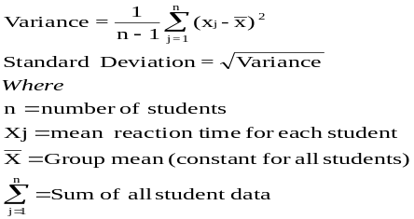
Calculate the variance and standard deviation for 5 students with data from Random Trial 2 (Table 11.4) and from Fixed Interval Trial 2 (Table 11.5)
Table 11.4: Random Trial 2 Data (Nondominant hand)
 | ENTER |  | ENTER |  | CALCULATE |  | CALCULATE
 | Mean Reaction time for Student |  | Group Mean |  | Deviation |  | Deviation²
Student | 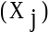 |  | 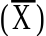 |  | 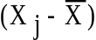 |  | 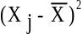
1
2
3
4
5
 |  | Sum the data for all students = |  | 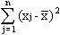 |  | =
Variance (σ²) = |  | Multiply by 0.25 = |  |  |  | =
Standard Deviation = |  | Take the square root of the variance = |  |  |  | =

Table 11.5: Fixed Interval Trial 2 Data (Nondominant hand)
 | ENTER |  | ENTER |  | CALCULATE |  | CALCULATE
 | Mean Reaction time for Student |  | Group Mean |  | Deviation |  | Deviation²
Student
1
2
3
4
5
 |  | Sum the data for all students = |  |  |  | =
Variance (σ²) = |  | Multiply by 0.25 = |  |  |  | =
Standard Deviation = |  | Take the square root of the variance = |  |  |  | =
- Questions
- What are the essential elements of a stimulus-response pathway? List them in correct sequence.

- Explain the difference between a voluntary reaction to a stimulus and a reflex response to a stimulus.

- Reaction time using a dominant, voluntary motor pathway is usually shorter than when using an equivalent nondominant pathway. Explain.

- Reaction times associated with repetitive fixed interval stimuli in a given stimulus-response situation usually decrease over a short time period to some minimal value and then remain stable. Explain.

III. OPTIONAL Active Learning Portion
- Hypothesis

- Materials

- Method

- Set Up

- Experimental Results

End of Lesson 11 Data Report

